Group Assignment:   
Final Project Proposal

**The Sojourner Syntax**

***Team Delos Solo***

**Team Members**

1. ***5025201159 – Mohammed Fachry Dwi Handoko***

## Overview

An interactive landing page made with modern Javascript and CSS frameworks, featuring a look and In-depth exploration of realistic, "hard sci-fi" [Newtonian] spaceship designs. 3D models and parallax scrolls are top-priorities in terms of assets, and will serve to display data or informative content regarding said models, with each being separate components in a highlighted carousel section.

The second section will feature 'items', 3D models accompanied by a general description to serve as a selector for the main carousel section, whilst the third serve as a "unit-testing" area, where models could be selected and played as a simple, dynamic mini-game with sprites.

A footer will serve as a link towards the developer's social media - **let's keep in touch !**

## 3D Environment Sketch

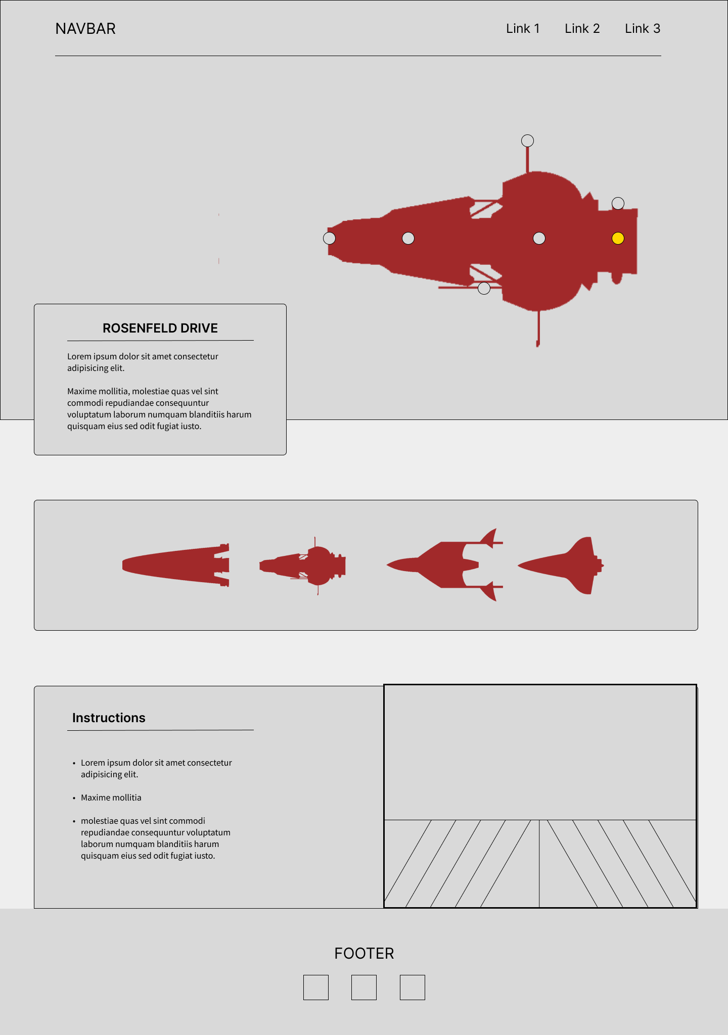

## Interaction and Technology

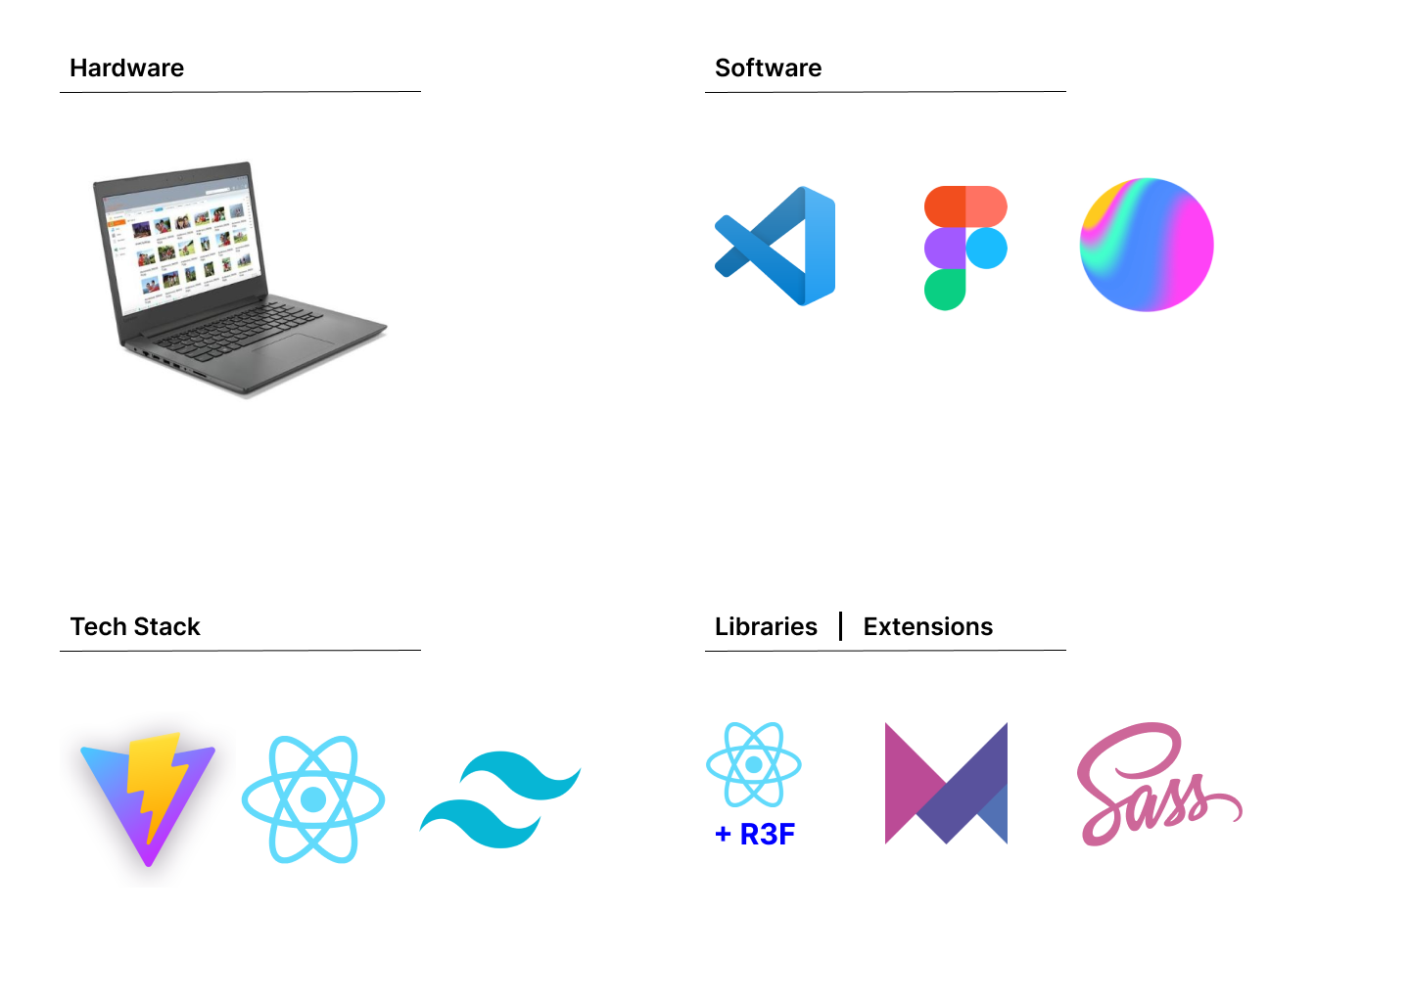

**HARDWARE :**

- LENOVO IDEAPAD 130-14AST

**SOFTWARE :**

- Microsoft Visual Studio Code > Figma > Spline

**TECH STACK :**

- Vite + React > Tailwind CSS

**LIBRARIES | EXTENSIONS :**

- React-Three-Fiber > Framer-Motion > SCSS

## Graphics Techniques

**- Point light, hemisphere shading, texture mapping, orbit control, translucency, sprites**

## Object Dynamic

### Local Variable

**1. Framer-Motion**

**2. Material UI Kit (MUI)**

**3. Styled-Components**

### External Variable

**1. React-Spline**

**2. React-Three-Fiber (R3F)**

**3. .ENV file (RESTful APIs)**

**4. Tailwind CSS | globals.scss**

**5. Hygraph (GraphQL CMS)**